1. Set your username and email in git config

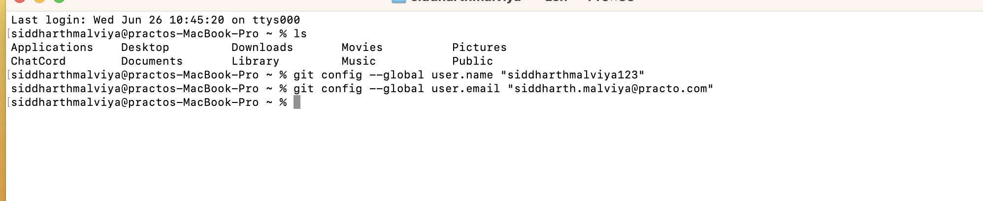

1. Create a new branch named "feature-branch" and switch to it.

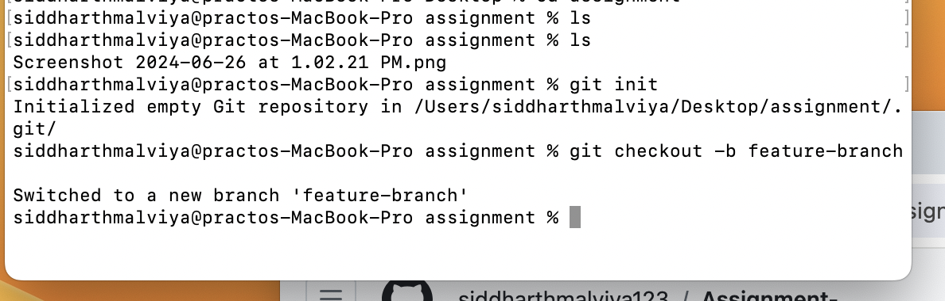

git checkout -b feature-branch

1. List all branches in the repository.

git branch



1. Delete the branch “feature-branch”

git branch -d feature-branch

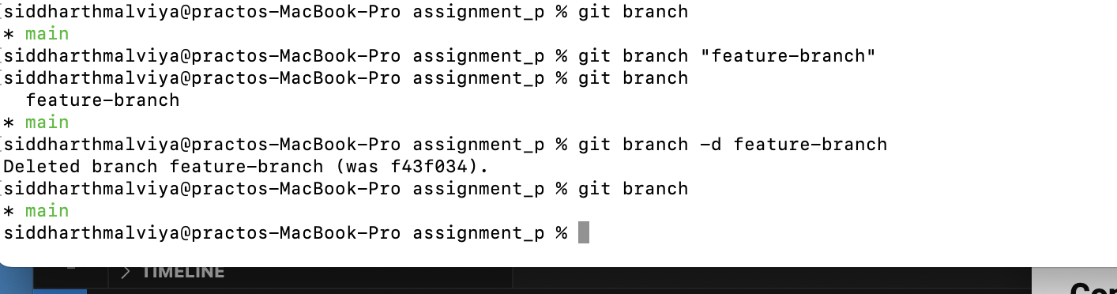

1. How do you undo the last commit

git revert HEAD

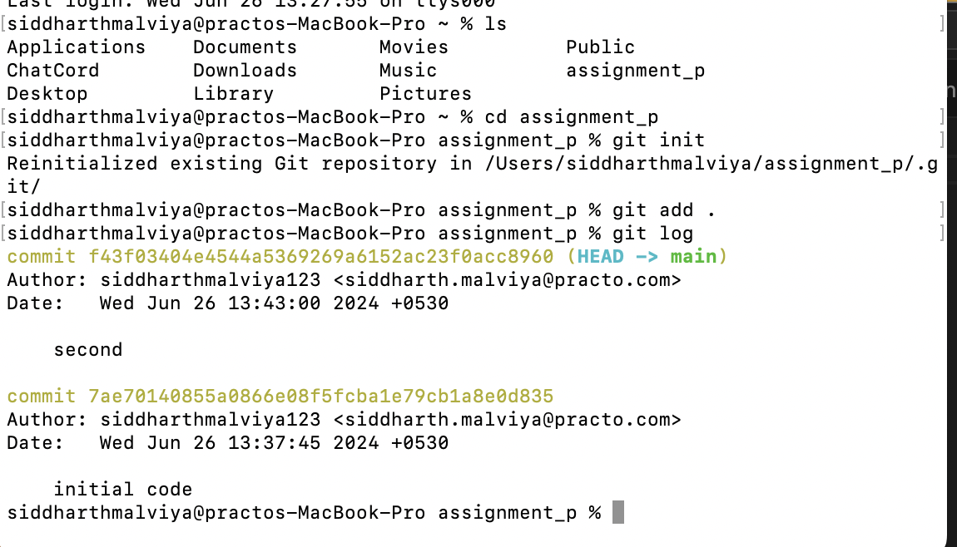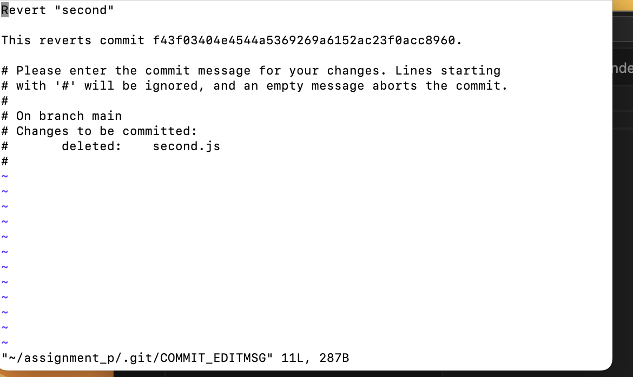

1. Create a new branch names “conflict-branch”

git checkout-b conflict-branch

1. Create a another branch named “feature1”

git checkout -b feature1

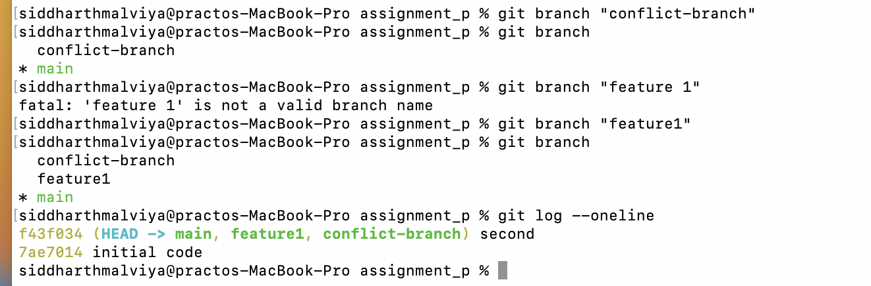

1. Make some changes in to feature1 branch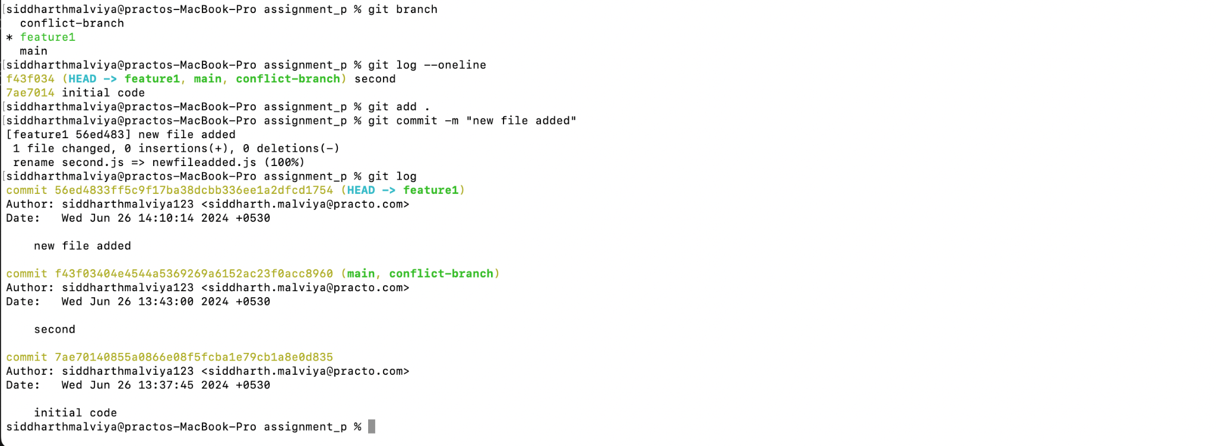
2. Merge “feature1” branch into main branch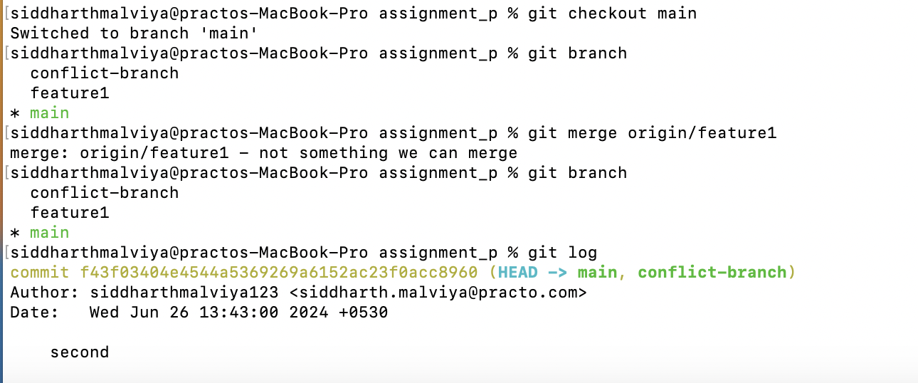
3. Make changes in “conflict-branch”, in the same file and line that you had made changes in feature1

Same above command : git checkout conflict-branch

Git add .

git commit -m “made conflicting changes”

1. Merge master into conflict-branch [Attach screenshot of terminal & file]

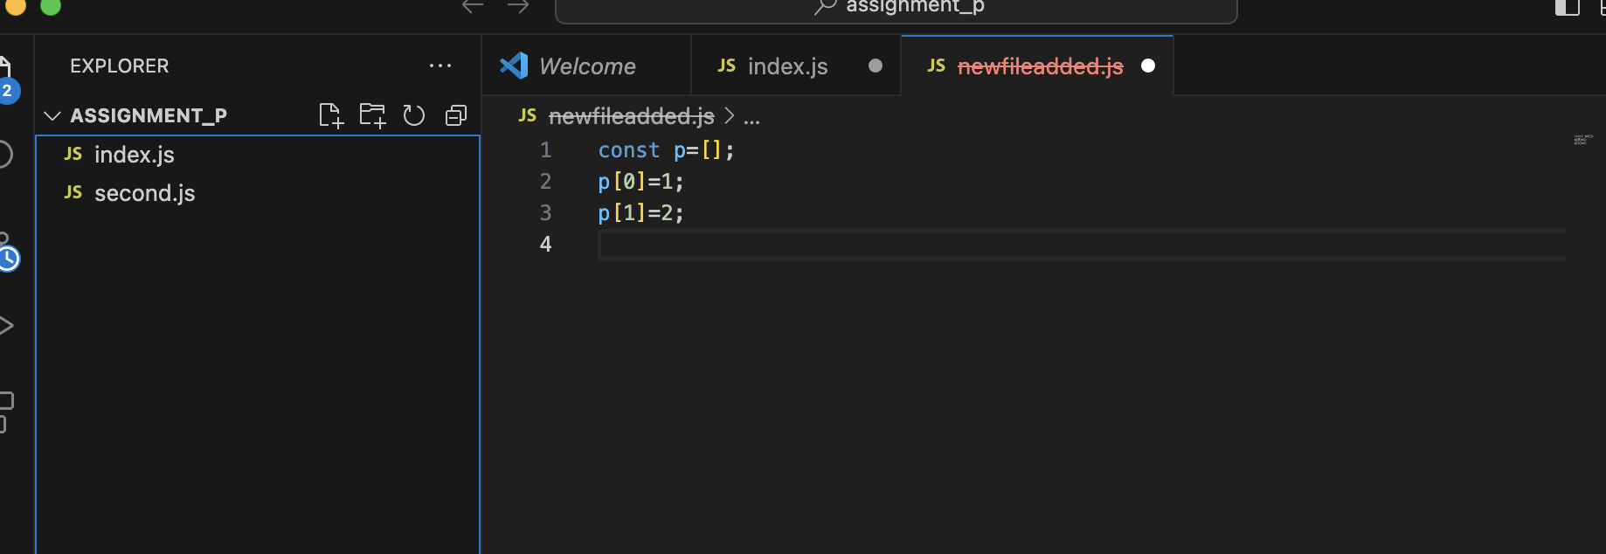

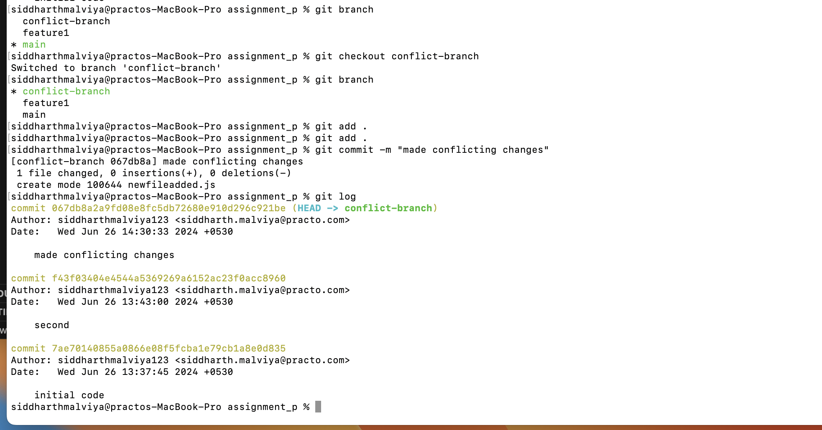

1. Resolve merge conflicts

It was done manually and then added

Git checkout conflict-branch

Git merge main

// conflict resolve

Git add .

Git commit -m “merger main into conflict-branch”

1. Add a remote named "origin" pointing to a GitHub repository.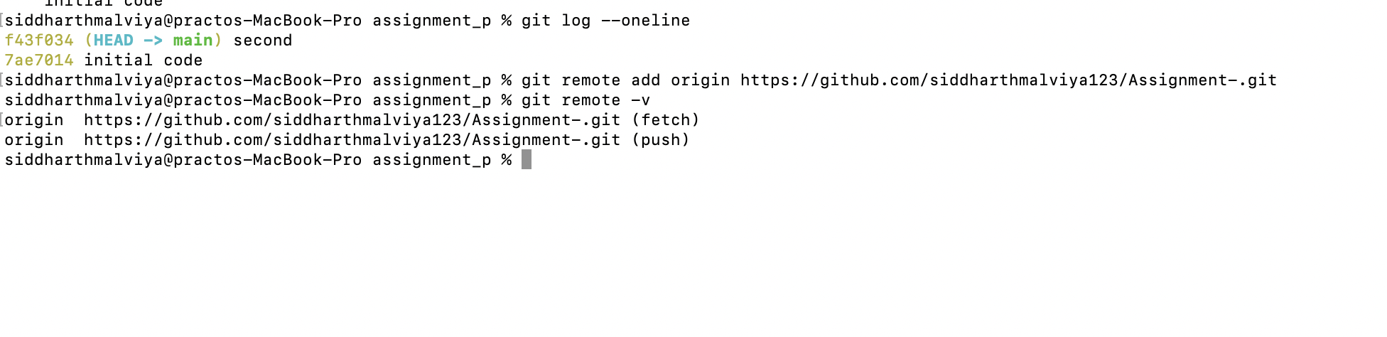
2. Fork a repository on GitHub and clone it to your local machine.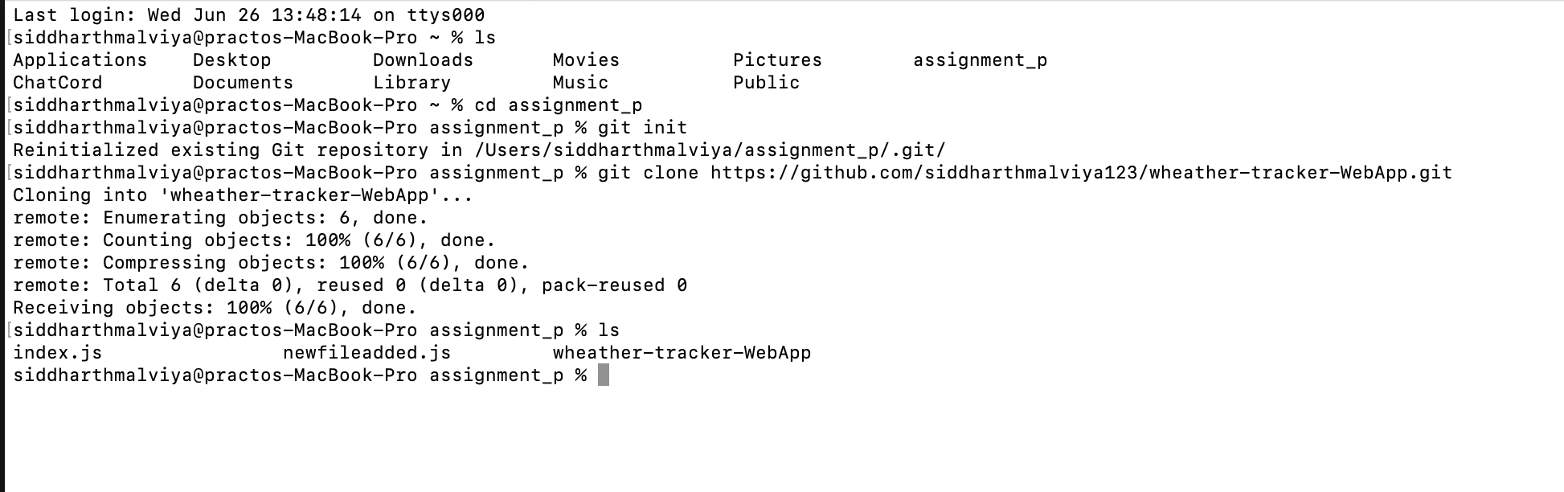
3. Create a new branch on your fork, make changes, and open a pull request to the original repository.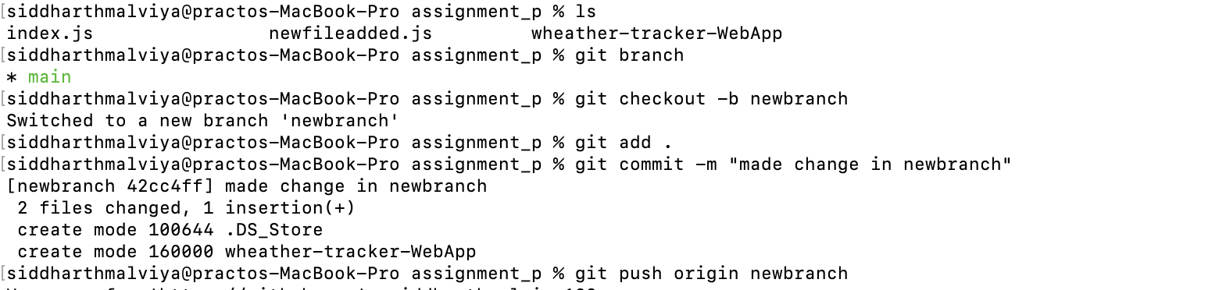
4. Comment on a PR and suggest improvements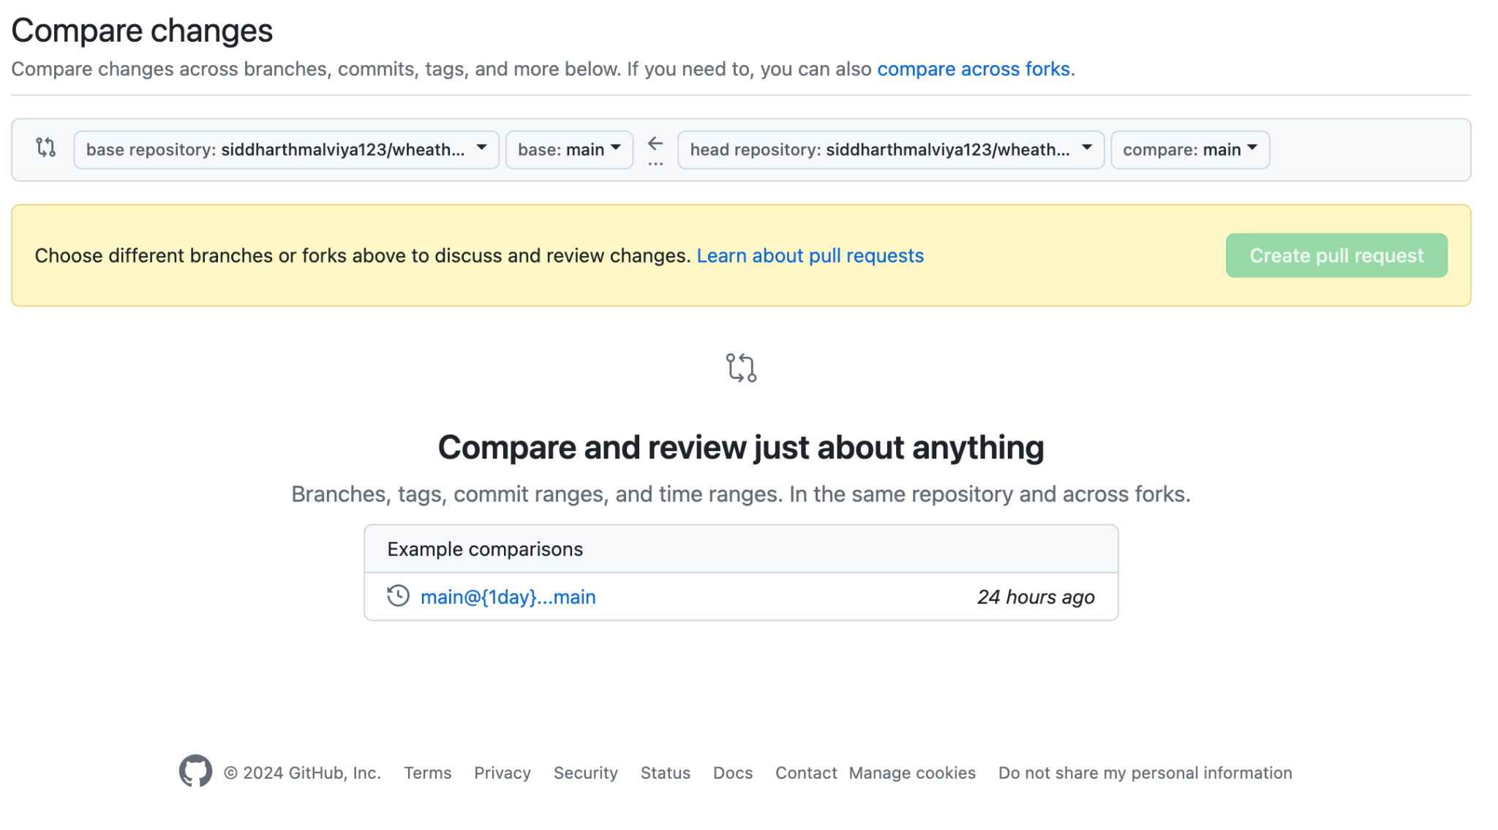
5. Create a Git alias for the command `git log --oneline` named `gitlol`.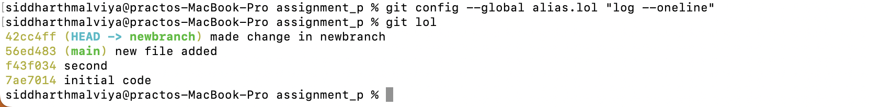
6. Create a pre-commit hook
7. You have made local changes in your branch, but you need to switch to another branch urgently without committing. How would you handle this situation?

We will use stash here stash temporarily stores

: git stash

git checkout otherbranch

//stashed changes

git stash app

1. You accidentally deleted a file in your local repository. How do you restore it using Git?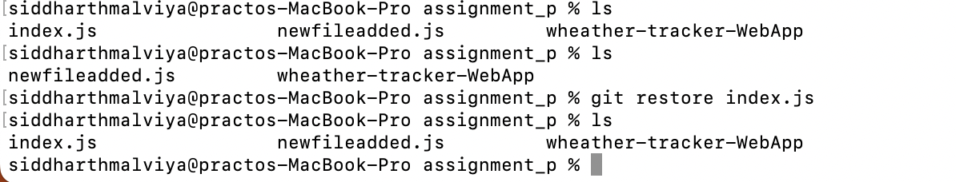
2. You have committed changes to your branch but forgot to include a file. How do you add the file to the last commit without creating a new commit?

We use –amend here to changes in the last recent comment

For eg.

Git add filewhichforgetted

Git commit –amend

1. You want to discard all changes in your working directory and revert to the last commit. What Git command would you use?

git reset - - hard

This will discard all changes in working directory and resets to last commit

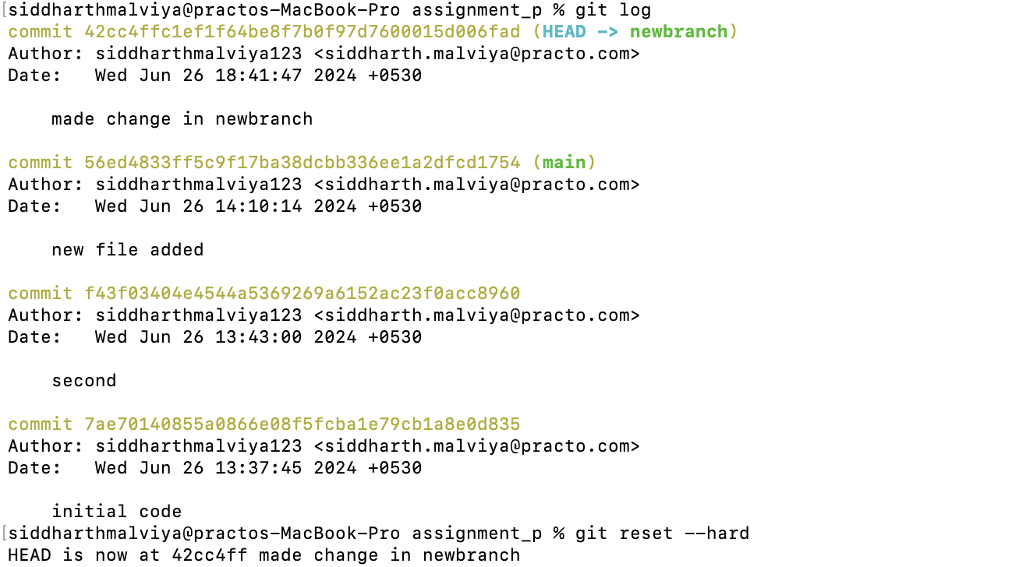

1. You need to view a specific commit's changes. What Git command can be used to show the changes introduced by a particular commit?

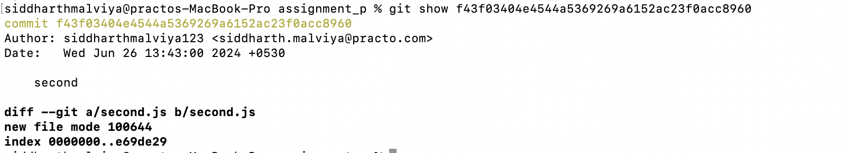

I used git show <commit id> here

1. You want to change a commit message, after you have already committed, how do you do so?

We use git commit —amend

After that the text editor configure for git and edit commit msg

1. Your colleague has made changes in their branch, and you want to incorporate those changes into your branch without merging. How do you achieve this?

By using stash

Or

git fetch origin

Git cherry-pick commit-hash

1. You've made several commits on a branch, but you want to club them into a single commit before pushing to the remote repository. How would you do that?
2. You accidentally staged a file that you don't want to commit. How do you unstage it?

Git reset <filename>

When you stage a file using git add, Git takes a snapshot of the file's current state and adds it to the staging area. This means the file is marked to be included in the next commit. If you decide that you do not want to include this file in your next commit, you can unstage it. Unstaging a file removes it from the staging area, but the file itself remains unchanged in your working directory

1. You don’t want to commit files that have .yml in the end, and also files inside folder config. How do you do that?

Add those file in.gitignore file this file will not commit afterthat

1. You want to see a list of all the files changed in the last commit. What Git command would you use?

Git diff

1. You realize that your local branch is outdated, and you want to fetch the latest changes from the remote repository. How do you do this without merging?

We use git fetch here

Which only updates remote-tracking branches and reflect changes without automatically merging anything into your current branch

1. You accidentally deleted a branch. How do you recover it?

Git maintains a reflog file from there we recover it using

git checkout -b branchname branchid

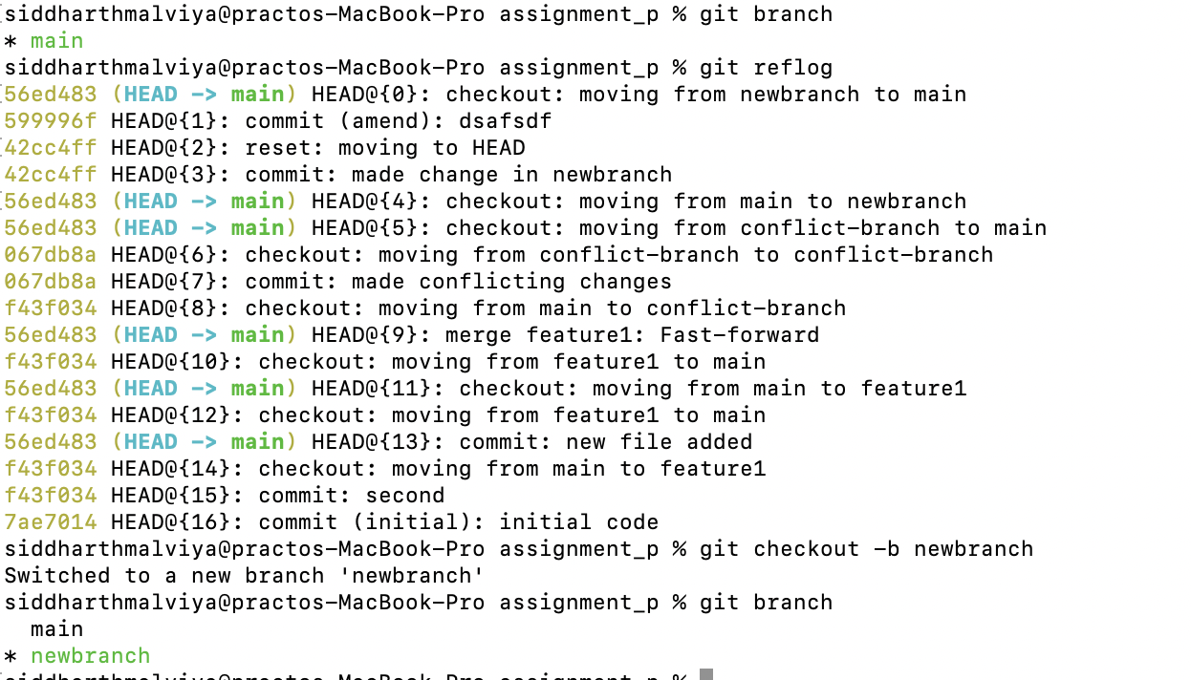

1. You want to remove untracked files and directories from your working directory. What Git command would you use?

git clean -fd

Here f for force and d for directory

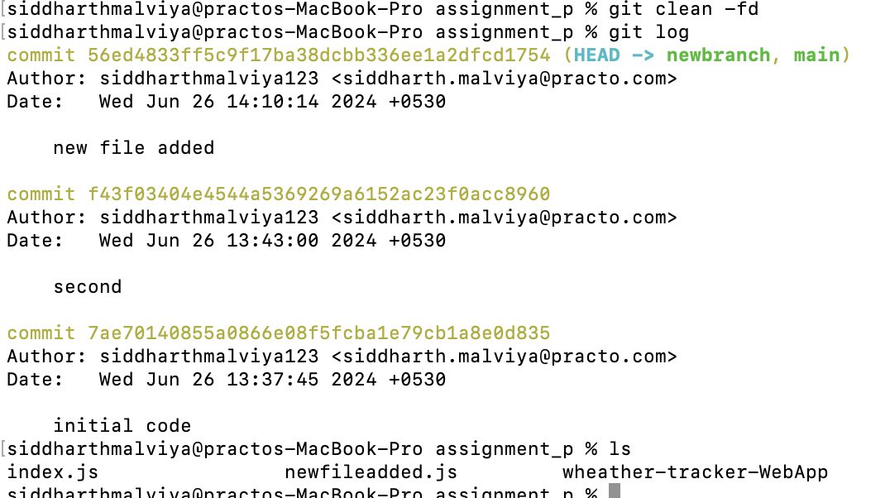

1. You have a commit from a feature branch that you want to apply to the main branch without merging the entire feature branch.

git checkout main

Git cherry-pick commitid

1. You mistakenly committed a change to the wrong branch and need to apply that commit to the correct branch.

Git log

Git checkout correctbranch

Git cherry-pick hashofwrong

Conflict resolution if any

Git push origin correctbranch

1. There is a series of commits on a feature branch, but you only want to cherry-pick a specific range of commits.

Git cherry-pick starcommithash^..endcommithash

1. You want to clone a GitHub repository onto your local machine, but you only need a specific branch. How can you achieve this?

Git clone –branch branch-name –single-branch <https://github.com/siddharthmalviya123/chatcord.git>

1. You've made changes to your local repository and want to push them to your fork on GitHub. What Git commands would you use?

Git add .

Git commit -m “commit message”

Git push origin branchname

1. You want to create a new branch both locally and on GitHub to work on a new feature. What commands would you use?

Git checkout -b newfeaturebranch

Git push -u origin newfeaturebranch

here,

-u→ upstream

1. You want to see the commit history of a GitHub repository. How can you do this using Git commands?

Git log

1. You've accidentally committed sensitive information and want to remove the commit from both your local and remote repositories on GitHub. What commands would you use?

Git log

Git rebase -i HEAD~n (where n is the number of commit to go back)

// After that command opens an interactive rebase editor where we can choose to edit , delete , // or squash commits change pick to edit and save file

Pick commithash

1. You want to delete a remote branch on GitHub. What Git command would you use?

Git push origin –delete branchname

1. Create a git repository for all your assignments and upload them in it. Ask your peers to code review it, and you need to code review your peers assignments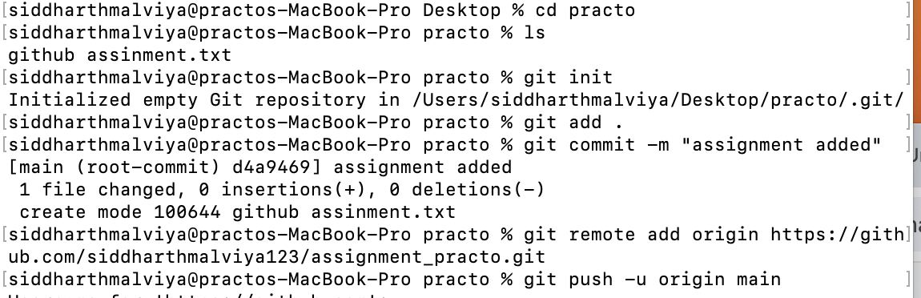

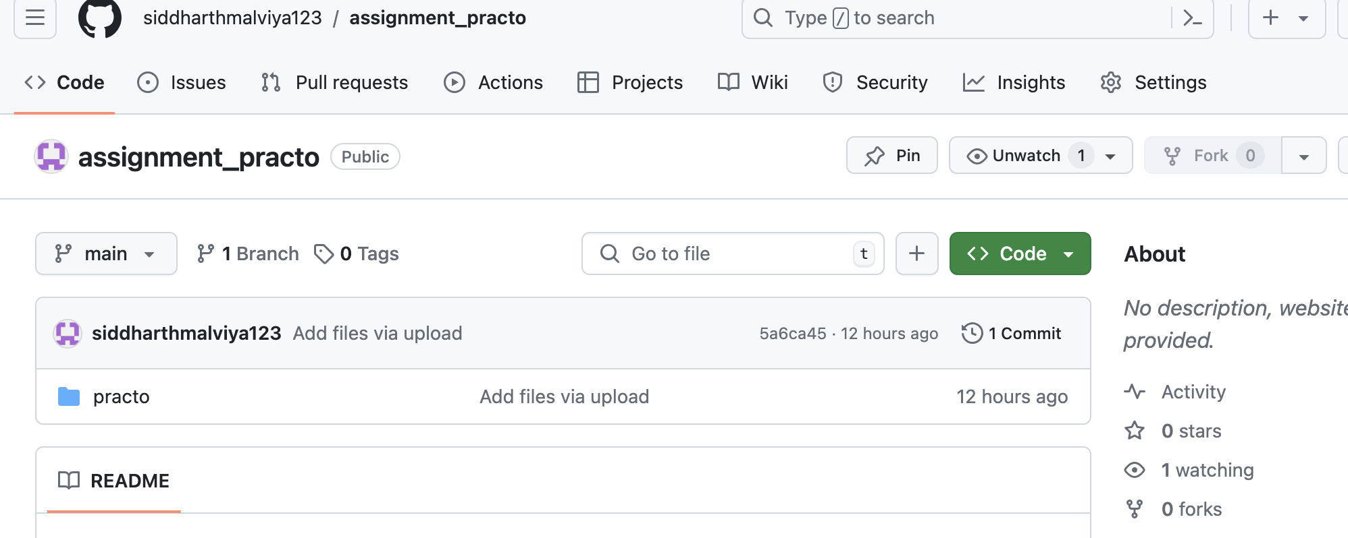

1. Create a pull request on any open source library on github, attach the pull request link to the readme file of this project’s repository

First step to clone

Git clone <https://github.com/siddharth123/chatcord.git>

Cd chatcord

//make readme file

Git add .

Git commit -m “readme added”

Git push origin main

Now after that we will go to repository and click on pull requests -> new pull request ->select base repo (original repo) and base branch (main or master)

->create pull request